Lab Assignment

- Consider the following relational database, where the primary keys are underlined.
Employee (person-name, street, city)
Works (person-name, company-name, salary)
Company (company-name, city)
Manages (person-name, manager-name)

a)Create the above tables in MySQL
b)Insert any three records in each of the above tables and display them.
c)Write the SQL for each of the following queries.

a). Find the names of all employees who work for First Bank Corporation.
b). Find the names and cities of residence of all employees who work for First Bank Corporation.
c). Find the names, street addresses, and cities of residence of all employees who work for First Bank Corporation and earn more than Rs 10,000 per annum.
d) Find the names of all employees in this database who do not work for First Bank Corporation.
e) Find all employees in the database who live in the same cities as the companies
for which they work.
f) Find all companies in which the average salary of an employee is more than 5000.
g) Update the salary of all the employees who work for First Bank Corporation by 10%.
h) Delete the records of all employees who work for First Bank Corporation.
i) Create a view to find the names, street addresses, and cities of residence of all employees who work for First Bank Corporation and earn more than Rs 10,000 per annum.

2) For the following relations
Members (mid, name, design, age)
Books (Bid, Btitle, BAuthor, Bpublisher, Bprice)
Reserves (mid, Bid, date)
Where Bid is book identification, Btitle is Book title, Bpublisher is book publisher, Bprice is Book price, mid is Members identification, and Desig is designation.

a)Create the above tables in MySQL
b)Insert any three records in each of the above tables and display them.
c)Write the SQL for each of the following queries.

- List the title of books reserved by professors older than 45 years
- Find ids of members who have not reserved books costing more than Rs. 500.
- Find the author and title of books reserved on 27 May 2007.
- Find the names of members who have reserved all books.
- Update the price of all the books by Rs 100 whose publisher name is ‘Asia Publication’
- Delete the records of all members whose age is less than 18.

3) Consider the following relational schema and write the relational algebra expression and SQL for the following.

Supplier
(supplier-id, supplier-name, city)
Supplies
(supplier-id, part-id, quantity)
Parts
(part-id, part-name, color, weight)

a)Find the name of all supplier located in city "Kathmandu".
b)Find the name of all parts supplied by "ABC Company".
c)Find the name of all parts that are supplied in quantity greater than 300.
d)Find the number of parts supplied by "ABC Company'.
e)Find the name of all suppliers who supply more than 30 different parts.

4) Consider the following relational schema and write the SQL for the following.

student(id, name)
enrolledIn(id, code)
subject(code, lecturer)

- What are the names of students enrolled in cs3020?
- Which subjects is Hector taking?
- Who teaches cs1500?
- Who teaches cs1500 or cs3020?
- Who teaches at least two different subjects?
- What are the names of students in cs1500 or cs3010?
- What are the names of students in both cs1500 and cs1200?
- What are the names of students in at least two different subjects?
- What are the codes of all the subjects taught?
- What are the names of all the students?
- What are the names of all the students in cs1500?
- What are the names of students taking a subject taught by Roger?
- What are the names of students who are taking a subject not taught by Roger?

5) Consider the following relational database.

Student(snum: integer, sname: string, major: string, level: string, age: integer)
Class(name: string, meets at: time, room: string, fid: integer)
Enrolled(snum: integer, cname: string)
Faculty(fid: integer, fname: string, deptid: integer)

Write the SQL for each of the following queries.
- Find the names of all Juniors (Level = JR) who are enrolled in a class taught by I. Teach.
- Find the age of the oldest student who is either a History major or is enrolled in a course taught by I. Teach.
- Find the names of all classes that either meet in room R128 or have five or more students enrolled.
- Print the Level and the average age of students for that Level, for each Level.

- Find the names of students who are not enrolled in any class.

6. Consider the following database schema. What are the referential integrity constraints that should be held on the schema? Write appropriate SQL DDL statements to define the database.
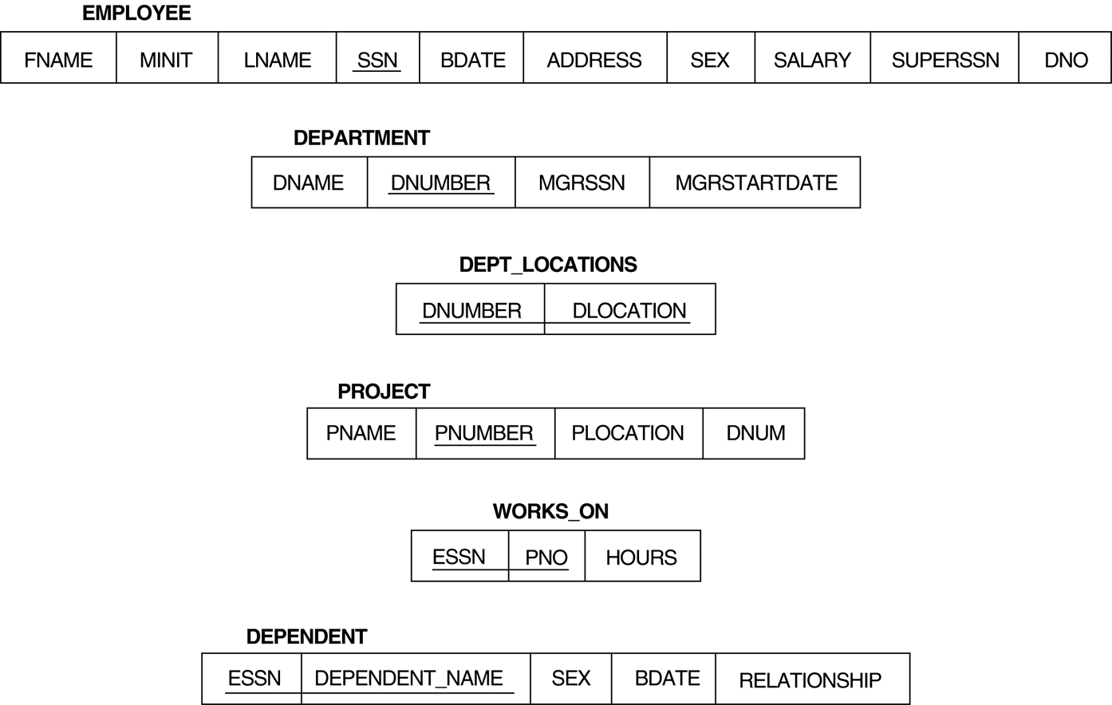

Write the SQL queries for the following:

- Retrieve the name and address of all employees who work for the ‘Research’ department.
- For every project located in ‘Stafford’, list the project number, the controlling department number, and the department manager’s last name, address, and birth date.
- Find the names of employees who work on all the projects controlled by department number 5.
- Make a list of project numbers for projects that involve an employee whose last name is ‘Smith’, either as a worker or as a manager of the department that controls the project.
- List the names of all employees with two or more dependents
- List the names of managers who have at least one dependent
- Retrieve the names of employees who have no dependents.

7. What is the view? And explain the advantages of view. Write command to create view of employees working in IT department.

Note: While doing the assignment, you should write the command and screenshot for DDL and DML statements.

